v - ASSIGNMENT

1. Write a python program to reverse a number using a while loop.

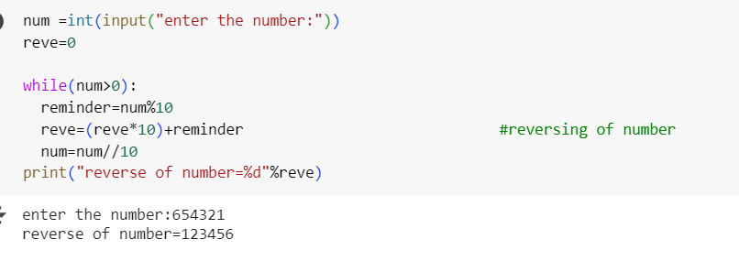

Output

Enter a number:654321

Reverse of number: 123456

1. Write a python program to check whether a number is palindrome or not. 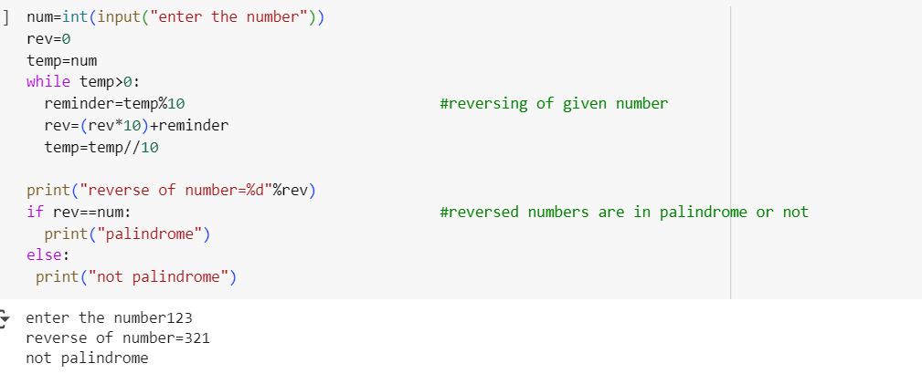

Output

Enter a number:123

Reverse of number:321

Not palindrome

1. Write a python program finding the factorial of a given number using awhile loop. 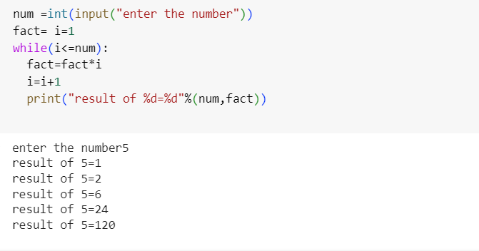

Output

Enter a number: 5

Result =120

1. Accept numbers using input () function until the user enters (). If user input () then break the while loop and display the sum of all numbers. 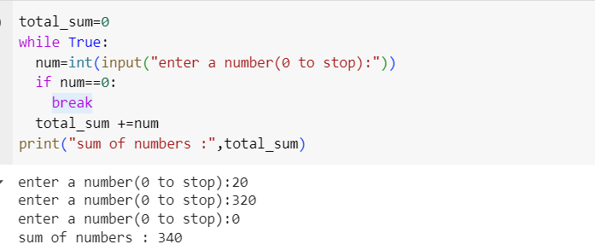

Output

Enter a number:20

Enter a number:320

Enter a number:0

Sum of numbers:340